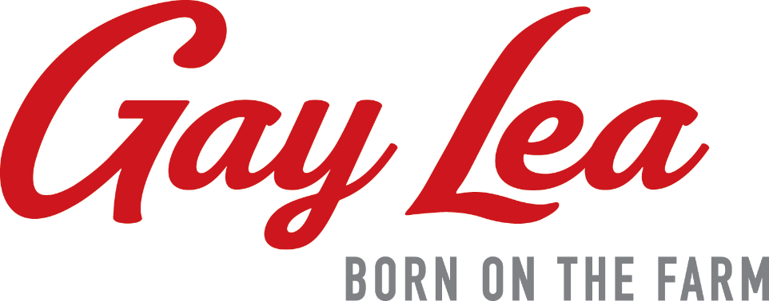

2022 Zone Annual Meeting Dates
Registration at 9:30am Meeting Starts at 10:30am
Zone 1 – Tuesday, November 29
Stratford Rotary Complex
353 McCarthy Rd., Stratford, ON N5A 7S7

Zone 2 – Wednesday, November 30
Ancaster Fairgrounds Merritt Hall
630 Trinity Rd. South, Jerseyville, ON L0R 1R0

Zone 3 – Thursday, December 1
Teeswater Community Centre
19 Marcy St. Teeswater, ON N0G 2S0

Zone 4 – Thursday, November 24
North Grenville Municipal Centre
285 County Rd 44 Kemptville, ON K0G 1J0

